SOAP API

🔹 What is a SOAP API?
# Source: Chatgpt (GPT-5-Mini) at [1/19/2026]
SOAP API stands for Simple Object Access Protocol Application Programming Interface. It's a protocol used for exchanging structured information in the implementation of web services—especially between different platforms and programming languages.
Unlike REST (which is more flexible and lightweight), SOAP is strict and formal, designed for reliable and secure communication, often used in enterprise-level applications like banking, insurance, or government systems.

✅ Key Characteristics of SOAP:
# Source: Chatgpt (GPT-5-Mini) at [1/19/2026]
Feature | Description
Protocol | SOAP is a protocol, not an architectural style like REST.
Format | Uses XML only (no JSON).
Transport | Usually over HTTP, but can use SMTP, FTP, etc.
Strict Structure | Requires a WSDL (Web Services Description Language) file that describes the service and expected messages.
Built-in Standards | Includes support for security, transactions, message validation, and more.

🔍 Example SOAP Message (Request):
# Source: Chatgpt (GPT-5-Mini) at [1/19/2026]
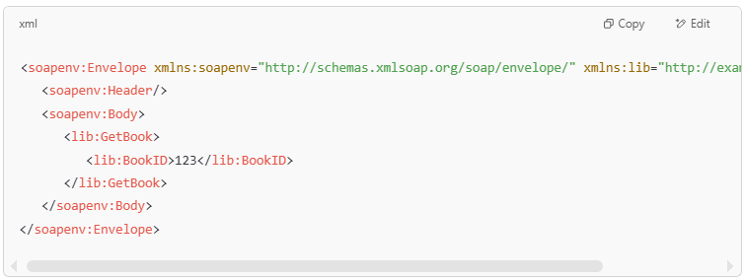
<soapenv:Envelope xmlns:soapenv="http://schemas.xmlsoap.org/soap/envelope/" xmlns:lib="http://example.com/library">
<soapenv:Header/>
<soapenv:Body>
<lib:GetBook>
<lib:BookID>123</lib:BookID>
</lib:GetBook>
</soapenv:Body>
</soapenv:Envelope>

This would request information about a book with ID 123.

🆚 SOAP vs. REST:
# Source: Chatgpt (GPT-5-Mini) at [1/19/2026]
Feature | SOAP | REST
Protocol Type | Protocol | Architectural style
Data Format | XML only | Mostly JSON, but supports others
Speed | Slower | Faster and lightweight
Security | Built-in (WS-Security) | Uses HTTPS, external tools
Ease of Use | More complex | Easier, especially for web/mobile
Best For | Enterprise, financial systems | Web apps, mobile apps, microservices

🧠 In Summary:
# Source: Chatgpt (GPT-5-Mini) at [1/19/2026]
A SOAP API is a strict, XML-based protocol for web services that provides powerful features for complex, secure, and structured communication—but is heavier and harder to work with than REST.
Would you like an example of how to call a SOAP API using tools like curl or Postman?

